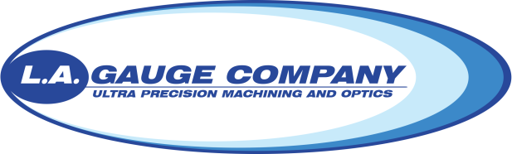

Materials Expeditor

LA Gauge is looking for highly motivated team players who are interested in pursuing a career in manufacturing and planning. Experience in a warehouse and/or machine shop is a plus, but not a requirement. We will walk you through a hands-on training and teach you what you need to be successful.

LA Gauge specializes in ultra-precision machining and optics capabilities to the aerospace, defense, and commercial industries. We specialize in machining and polishing components used in nuclear reactors, guidance systems, satellites, and targeting systems holding machining tolerances to 50 millionths of an inch, and polishing tolerances to the billionths (angstroms). We machine materials of all kinds to meet our customer’s needs, including beryllium and titanium.

The person in this role will support our daily efforts to produce parts per our tight schedules. Much of the time will be spend on the shop floor working directly with manufacturing and quality engineers, inspectors, machinists, vendors, and tradesmen. This individual should be able to follow specific directions and able to carry material/parts up to 50 lbs. This is a great first step for candidates interested in pursuing a career in lean manufacturing and operation analytics. We are growing quickly and need energetic, personable, and detail-oriented people to join our team!

The person successful in this job will:
- Move material/parts and track their status
- Maintain an extraordinary attention to detail
- Be energetic, fast paced, and self-motivated
- Display a positive, can-do attitude
- Take full ownership of the goals set and will take a hands-on approach
- Have a desire to be coached to improve and take on additional responsibility
- Attention to detail

Requirements for this position:
- High School Graduate/GED
- Some college preferred
- Microsoft Office Proficient
- Manufacturing Experience is a PLUS

LA Gauge is proud to provide very competitive employee packages, including:
- Competitive pay
- Medical insurance
- Dental insurance
- Vision insurance
- 401K Retirement Plan with 50% Company matching
- Paid Time Off (2 weeks to start)
- Life and AD&D Insurance
- Company pays for job related skill development classes
- Employee bonus referral program

Email resume to nnascimento@lagauge.com

